Task 3

lab3: SINGLE Knife-edge diffraction

NAME: ABDELRAHMAN MATARAWY SAYED SECTION: 5

**Objectives:**

* Observing the effect of single knife -edge diffraction.
* Implementing the single knife -edge diffraction model in MATLAB.

 Fresnel-Kirchhoff diffraction parameter equation:

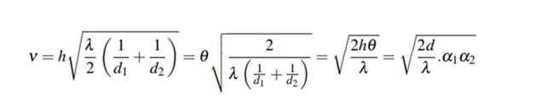

 diffraction gain (or loss) equation:

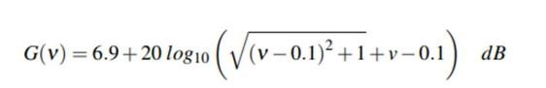

“For the case where v > −0.7”

**Task3:**

1. Implement a function that calculates the diffraction loss given d1 d2, f and h.

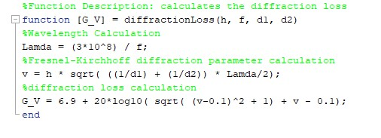

1. Using the function implemented in (a) determine the diffraction loss incurred for d1=10 Km, d2 = 5 Km and h = 20 m at frequency 10 GHz.

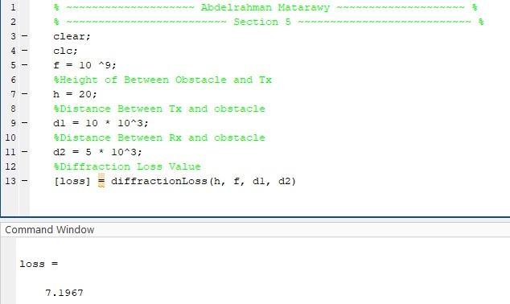

1. Implement a function that calculates the diffraction loss given the Fresnel-Kirchoff diffraction parameter.

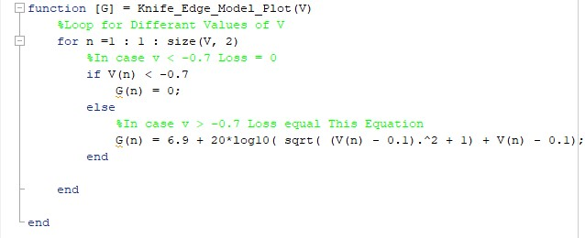

1. Use the function in (c) to plot the diffraction gain versus the Fresnel – Kirchoff parameter. Take the range of v from -5 to 20. (any value less than -0.7 assume the gain = 0 dB).

